Helen Little 870 words

Lowry, Laurence Stephen (1887 – 1976)

L. S. Lowry was a modern British artist celebrated for his depictions of Salford and Manchester. As well as making portraits, landscapes and seascapes, he is best known for painting what the artist called ‘the industrial scene’, by which he meant the physical fabric of Britain’s industrial north, its distinctive sense of place and accompanying phenomenon of working class culture. Often populated with crowds of people set amidst a backdrop of terraced streets, mills and factories, Lowry’s urban scenes speak to the region’s identity as pioneer of the industrial revolution as well as the radical social, economic and environmental upheaval of the early twentieth century. Lowry is commonly perceived to be a provincial and uniquely British artist, yet part of his story is that in Manchester he made a vital connection with late-19th century French painting. In 1905 Lowry studied at Manchester Municipal College of Art under the talented late Impressionist Adolphe Valette (1876-1942) who introduced him to Impressionism. After discovering new artistic possibilities and beauty in his industrial environment, Lowry’s early paintings and drawings revealed a great pathos for the unlovely aspects of the city. Like the French painters of modern life Camille Pissarro (1830-1903), Georges Seurat (1859-1891) and Vincent van Gogh (1853-1890), Lowry shared a deep unease with the present and his place in it – which the French poet and critic Charles Baudelaire (1821-1867) characterised as a defining characteristic of modern life.

Lowry was born in 1887 in Stretford, Manchester. His father was an estate agent and his mother had aspirations to become a concert pianist. They lived in a relatively affluent middle class area of Victoria Park until 1909 when the family were forced by financial circumstances to move to the less respectable area of Pendlebury in Salford, where for the first time Lowry was able to walk from his home and encounter crowded streets dominated by factories, cotton mills and coal mines. The following year Lowry took a job as a rent collector with the Manchester Pall Mall Property Company, a fact he concealed from the art world.

Walking the streets of Manchester on his daily round, Lowry witnessed the lives of ordinary people and the everyday dramas, incidents, and tragedies that became the raw material for his art. A distinctive characteristic of Lowry's paintings from the late 1920s onwards is his use of a shadowless white background, which gives his pictures a raw and dreamlike quality. Though he knew the streets of Salford intimately, Lowry’s art is not straightforwardly realist and he often created images from his memory or imagination, incorporating topographically accurate facets of the urban environment recorded in sketchbooks and drawings into new composite and experimental arrangements.

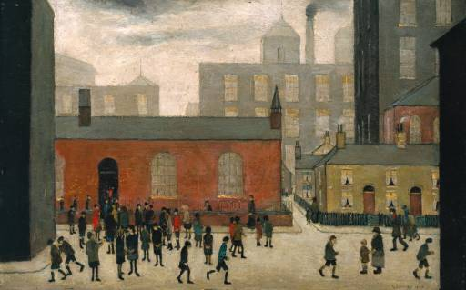
L. S. Lowry Coming out of School 1927

http://www.tate.org.uk/art/artworks/lowry-coming-out-of-school-n05912

During the 1930s and 40s Lowry’s work shifted from an emphasis on human social interaction to the impact of industrialisation on nature with a series of bleak, apocalyptic landscapes that were recognised as symptomatic of a crisis of nostalgia, anxiety and uncertainty that was gaining currency in the art of Graham Sutherland (1903-1980) and Francis Bacon (1909-1992). After the Second World War his images became increasingly caricatured in style as he responded to the new optimism of the working class under the Labour government, painting seaside holidays and other new leisure pursuits and the Queen’s Coronation as well as a series of portraits of outcasts and misfits of society. Lowry always considered himself an enemy of social distinction and at the height of his dominance in the British art world during the 1950s he declined an OBE, a CBE, a knighthood, and the Companion of Honour, holding the record for the highest number of declined honours.

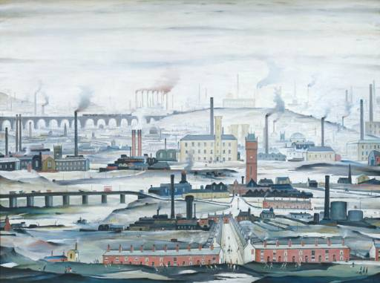
L. S. Lowry Industrial Landscape 1955

http://www.tate.org.uk/art/artworks/lowry-industrial-landscape-t00111

In 1952 Lowry retired aged 65 with a full pension from the Pall Mall Property Company, the same year the first monograph on his art was published. In it Lowry is laid down as one of the originals of modern art whose voice lay within a tradition of the eccentric and isolated outsider, untainted by the avant-garde. After his retirement Lowry travelled extensively throughout the British Isles, painting among other things rural landscapes in Cornwall and the North East coast. In 1950 Lowry was commissioned to paint a large canvas for the Festival of Britain exhibition 60 Paintings for 51 which renewed his interest in the industrial landscape, kick-starting a series of large panoramas that respond to Britain’s rapid industrial decline, their tone of collapse and loss bidding farewell to the subject he had made his own.

Lowry died on 23 February 1976 at Woods Hospital, Glossop, following an attack of pneumonia. In September that year, the largest exhibition of Lowry’s work to date took place at The Royal Academy of Arts, London.

References and further reading:

Clark, T. J. and Wagner, Anne (2013) Lowry and the Painting of Modern Life (exh. cat), London, Tate Britain.
Howard, M and Wildman, C (2012) Lowry (exh. cat), Nottingham: Djanogly Art Gallery.
Howard, M (2000) Lowry: A Visionary Artist, Salford: Lowry Press.
Leber, M and Sandling, J (1995) L. S. Lowry, London: Phaidon Press.
Rhode, S (1999) L. S. Lowry: A Biography, Salford: Lowry Press.

